WORK REPORT
NAME – NAITIK NEGI DATE – 12-07-2026
WHAT I LEARN TODAY?
Embedding
Embedding using count vectorizer
Calling the functions
PROBLEM I FACED?
In calling the functions
Mistake of casing while calling functions
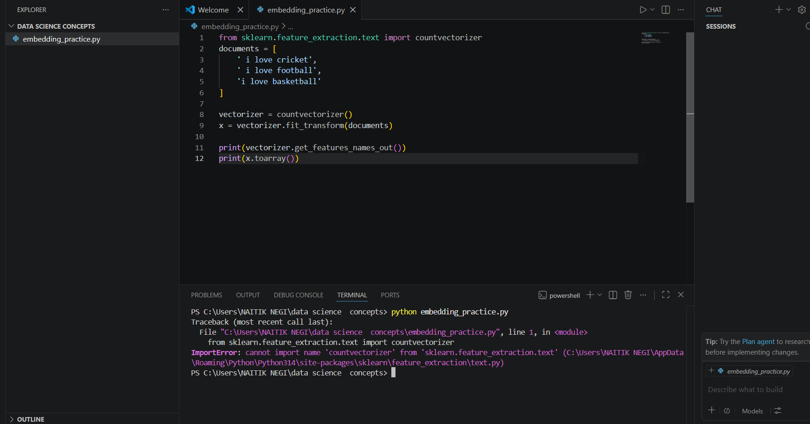
PRACTICAL IMPLIMENTATION?
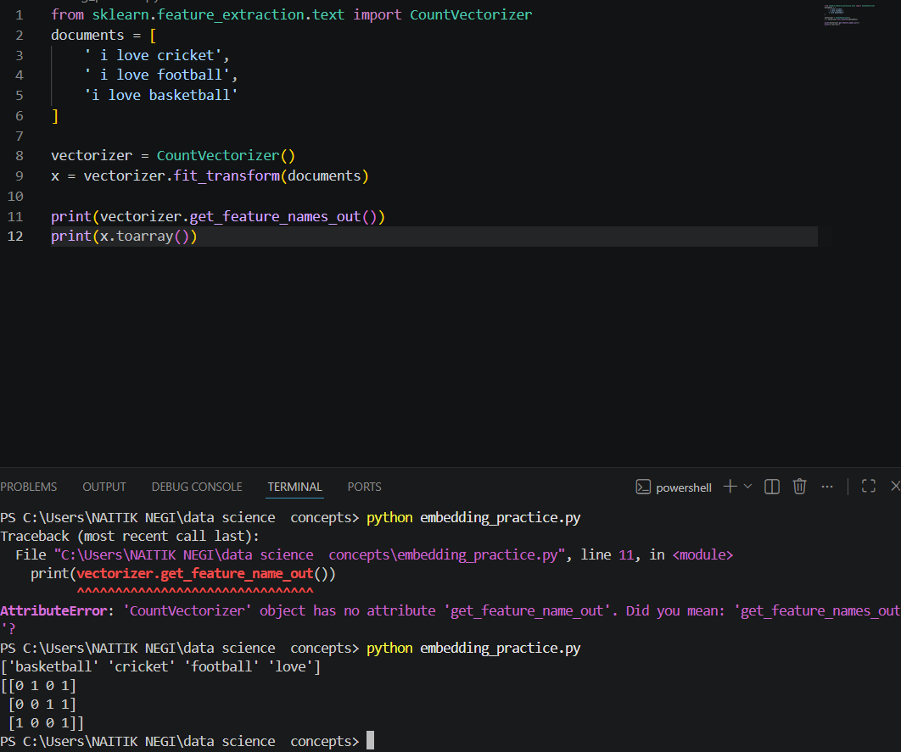
Thank you.

